Reflections on Standing Rock
Rev. Ron Martin-Dent
Interim Pastor, Culbertson UMC and Froid/Medicine Lake UCC

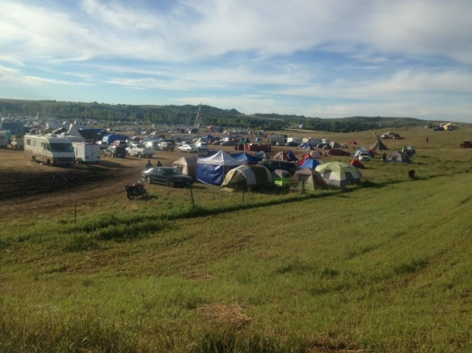
Accompaniment. We talk about it in our church, but I, along with Pastor Linda Webster of Our Saviours Lutheran at Rocky Boy, was blessed to accompany the people of Standing Rock early September to witness a truly powerful spirit filled action. The Standing Rock Sioux have gathered and taken legal action to halt the construction of the Dakota Access Pipe Line (DAPL) going under Lake Oahe on the Missouri River just upstream of their reservation. The people there fear that the pipeline may leak and pollute the reservation’s main source of drinking water. They also believe that construction has and will damage or destroy sacred burial and ceremonial sites. I wanted to be there to listen and learn, and see for myself what was happening.
Theirs is a deeply spiritual action. Standing Rock leaders emphasized over and over again the non-violent nature of their protection (not protest) movement. Weapons and drugs are banned from the campsite. They encouraged prayers, noting that spiritual power is stronger than violence. In Native American culture there is a tradition of the “Seven Generations”—we are the product of the seven generations that came before us, and we have a responsibility to the seven generations which will follow us. So many of the people I talked with and heard shared that they were doing this not for themselves but for their children and grandchildren. Their main “slogan” on signs and statements is “Water is Life.” As one person I talked with said, “They took our land and we are still there, but if they take our water we will die.”
In an unprecedented development, representatives of over 250 nations around the U.S., Canada, Hawaii, Ecuador, New Zealand, and others, have gathered at the Seven Councils Campground to express solidarity with their efforts. This has never happened. Traditional enemies greeted one another, danced, drummed, sang, and prayed together, sharing their stories of broken treaties and efforts to halt encroachments on their land, water, mineral, and spiritual places. I perceived that this movement could be the beginning of a new era where the Native Americans discover that they have a powerful voice in uniting together.
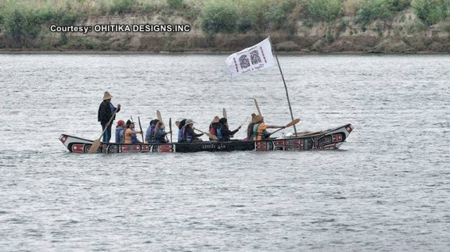
For example, in the 1970's many Northwest Native American Nations were fighting (successfully!!) to maintain their treaty fishing rights. The Standing Rock peoples went to support them. Now, in the middle of the salmon season, these coastal peoples have literally left their nets to support the Sioux people.
I was very impressed that it’s the young people of the tribe who have been the most active in this effort. Their involvement has been critical to the ongoing efforts of the tribe to stop the pipeline.
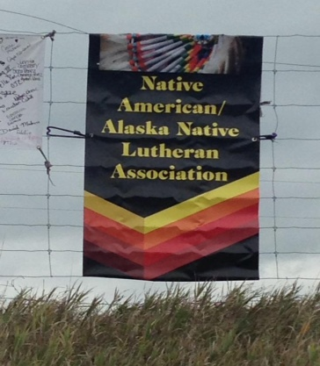
Need we agree with everything the nations support? Not necessarily. (Personally, I’m ambivalent over whether the alternatives of transporting oil by rail or truck are any more safe), but it is important to take seriously what THEY believe. These are our neighbors, often invisible, the survivors of centuries of white genocide (and yes, we are guilty of it!) and oppression. But as the people there said over and over again, “We are still here!” And we need to listen to their voices.
The participants I was with included both Lutherans and U.C.C. pastors and laity. We met briefly with the Episcopal pastor of the congregation at Cannon Ball on the reservation, and also saw three Lutheran pastors from North Dakota present one day, but weren’t aware of any other intentional Christian presence while we were there.
Our presence is important. We were watching one of the ceremonies honoring the graves which were disturbed where the encounter with the pipeline’s security personnel took place and I found myself standing next to a horse and its rider. He mentioned the horse was skittish as it was one of the horses bit by the dogs at the site. I asked if I could bless the horse, and he replied he would be honored, and thanked me for it. I felt blessed and honored also for in a small way witnessing to the love of Christ for ALL of creation, which was ultimately why we were there in the first place.
I would encourage you to, if you have the opportunity, to visit the Sacred Stone encampment to experience for yourself what is happening there. Whatever your opinions on the pipeline, I believe you will be inspired.

