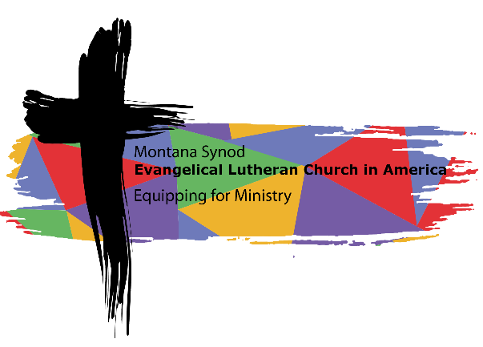
Oct. 6, 2023

Dear Church Council and Pastoral/Rostered leaders:

During your Church Council meeting in the coming weeks, you will likely be looking at the income and expenses in 2023 and will begin to set your budget for 2024 in order to be able to present that to your congregation at your Annual Meeting.
Recently you saw that I recorded a video Bible Study to be used in your congregation. The theme is from the passage from Ephesians 4 that the Synod Council, staff and other groups in the Synod have been prayerfully lifting up as a focus for all the activities in and through the Synod. In this packet, there is a shorter Bible Study on the same text that you can use to think about your own participation in the synod’s theme of Equipping for the Ministry of the Gospel. In this scripture text, the Apostle Paul writes,
¹¹The gifts [Christ] gave were that some would be apostles, some prophets, some evangelists, some pastors and teachers, ¹²to equip the saints for the work of ministry, for building up the body of Christ, ¹³until all of us come to the unity of the faith and of the knowledge of the Son of God, to maturity, to the measure of the full stature of Christ… ¹⁵speaking the truth in love, we must grow up in every way into him who is the head, into Christ, ¹⁶ from whom the whole body, joined and knit together by every ligament with which it is equipped, as each part is working properly, promotes the body’s growth in building itself up in love. (Eph. 4:11-16)

As Paul describes the body of Christ, knit and joined together, he states that Christ gives us gifts to equip us to promote the growth of the body of Christ so that it may build itself up in love. As members of the body of Christ, as congregations and members of the ELCA in the northern Wyoming and Montana Synod, we can envision with Paul that no one part of the synod functions separately from the other parts. Maybe another way to say that is what we each do as individuals and congregations matters for the sake of others across the synod and the wider church.
In Ephesians, Paul envisions the body of Christ as unity within diversity. He envisions oneness even amid separation and individuality. What a beautiful way to envision what it means for us to be “church” together! We live in a world where at times we think of our resources from a perspective that there isn’t enough. I do not think that Paul worried if there was enough, but rather trusted in the generous nature of God and the generous nature of God’s people.
As you consider the generosity and gifts received from Christ that you are sharing in your congregation, please also consider how to share of those gifts for the sake of “equipping for the ministry of the Gospel” within and beyond the Montana Synod. Together, we all equip and are equipped to be agents of grace and mercy for others. The materials included with this letter are provided to inform your conversation as you plan and commit to support the mission and work of the Montana and Northern Wyoming Synod and the whole church.

Blessings in Christ,
Rev. Laurie Jungling, Bishop

