Newsbrief: Early Translations of the Bible into English and Luther’s Influence
In the year 1525, William Tyndale began his life’s work, translating the Bible into English. It would be Tyndale’s greatest achievement towards the Reformation movement arising in England at the time. Tyndale’s intellectual abilities including his command of the English language along with his expertise in Greek, Latin and Hebrew allowed him to confidently translate the Bible.
What drove Tyndale to translate the Bible were his theology, his love of country, and his belief that every person no matter their station in life should be able to read the scriptures for themselves and interpret them. Above all it was his love of scripture. It would cost him his life.
Goo therefore and teache all nacions, baptisynge them in the name of the father, and the sonne, and the holy goost: Teachinge them to observe all thynges, whathsoever I commaunded you. And lo I am with you allwaye even untyll the ende off the worlde. (Matthew 28:19-20)

Much of William Tyndale’s theology comes from the biblical verse mentioned above.
The emphasis on reading Scripture began in the late 14th century with a bishop by the name of John Wycliffe. Wycliffe was not the first person in England to translate the Bible into the vernacular language, English, but it was his translation and theology, which precipitated later thought about scripture in the vernacular, that was to define the Lollard movement in England and eventually William Tyndale’s theology. The Lollards argued for an English Bible translation in order that every person have access to the word and promise of God given through his Son, Jesus Christ.
Using Scripture as a pre-requisite for a goodly existence on this earth was a major theme in Lollard theology and is prevalent in Tyndale’s own theology as well. We read in Tyndale’s own words:
The scripture is that where with God draweth vs vnto him and not where with we shuld be leade from him. The scriptures springe out of God and flow vnto Christe and were geven to leade vs to Christe. Thou must therefore goo alonge by the scripture as by a lyne vntyll thou come at Christ with is the wayes end and restinge place…
For William Tyndale, the process of translating the Bible into English began with knowledge of Greek, Hebrew, and Latin. He had access to Erasmus’s critical editions of scripture into Greek, Hebrew and Latin, as well as to Martin Luther’s German translation of the Bible. Tyndale used all these resources to help him in his translation of the New Testament. Tyndale was also a master of the English language: “He had scholarship, and Greek and Latin and he could learn Hebrew. He wrote in plain and powerful English, soaked with the cadence and rhythm he had learnt in his Oxford rhetoric classes.”
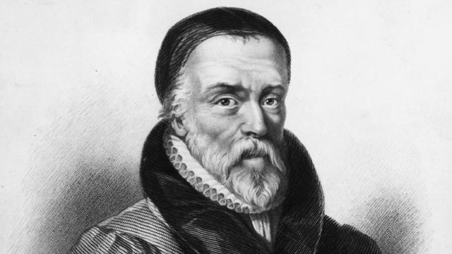
Tyndale had access to valuable resources in Protestant friendly regions of the Low Countries in Germany and Antwerp. Tyndale set out for Germany and arrived in the spring of 1524, never to return to England again. Tyndale formed a close group of associates upon his arrival in Germany. John Long gives two reasons as to why printers and others were willing to help Tyndale in his publication of his English-language Bible. He writes:

They helped Tyndale for two reasons: One was their genuine interest in promoting the availability of Scripture in the English language as an aid to the Reformation; the other was the lure of the economic profit for themselves they envisioned as possibly being forthcoming from Tyndale’s efforts because of the promising market in England for English-language Bibles.

A year later, in 1526, copies of the first edition of the New Testament arrived in England and became immediately popular and widely read among the ordinary peoples. Three more editions of the New Testament were published before Tyndale’s death in 1536.

The second edition appeared in 1534, with significant improvements. As John Long states, “It was a significant improvement over the first edition, with some 3,000 refinements incorporated into it. Among the changes, the marginal notes of the first edition that castigated the Roman clergy were largely omitted.” The third edition of the English-language Bible appeared in late 1534 or early 1535. This edition was further refined in translation than the second and included marginal notes as were in the first edition. Not much is known of Tyndale’s activities during the years between 1530 and mid-1534 except that copies of his translated of parts of the Old Testament began to appear.
The most significant of Tyndale’s editions was the third edition distributed in 1534, due to its marginal notes, which had been cut out of the second edition but were reintroduced from the first edition. It is known that Tyndale had a copy of Luther’s New Testament in German on his desk as he worked on his own translation in English. The question becomes, how much of Luther’s work did Tyndale take directly from Luther. There is no conclusive evidence of Tyndale and Luther ever meeting in person, but most scholars believe that Tyndale spent some time in Wittenberg and had the possibility of meeting or running into Luther. It was this possibility that gave reason for Tyndale’s enemies as well as friends to believe that Luther’s New Testament greatly influenced Tyndale’s New Testament. Levi Gruber writes, “In addition to part of the prologue, a great many notes and references are here traced to Luther.” In comparing Luther’s prologue with Tyndale’s, Gruber writes, “The point at which Tyndale directly begins to translate Luther, and his bodily appropriation of whole paragraphs, is, of course, readily recognized by the reader.”
In his marginal notes in his 1525 Cologne Fragment as well as his third edition of his New Testament, Tyndale includes many Lutheran ideas and even copies Luther’s words at times, much like he did with the prologue. Tyndale removed these marginal notes from his second edition but then reprinted them in his third edition. This in itself shows the influence of Luther on Tyndale. In his comparison study of Tyndale and Luther, Gruber includes sections of Luther’s Second Edition 1522 New Testament and sections of Tyndale’s Cologne Fragment 1525.

In 1536, William Tyndale was strangled and burned at the stake for heresy. What was his heresy? It was translating the Bible into English, along with having Lutheran sympathies. His dying words were, “Lord, open the King of England’s eyes.” Not long after Tyndale shouted these words from the stake was his prayer answered. It was answered by Miles Coverdale, who did what Tyndale was unable to do; translate the entire Bible into English. This first complete English Bible appeared in 1535, one year before Tyndale’s martyrdom. Most scholars are in agreement that Miles Coverdale was more of a compiler of other people’s translations of the Bible than a translator.

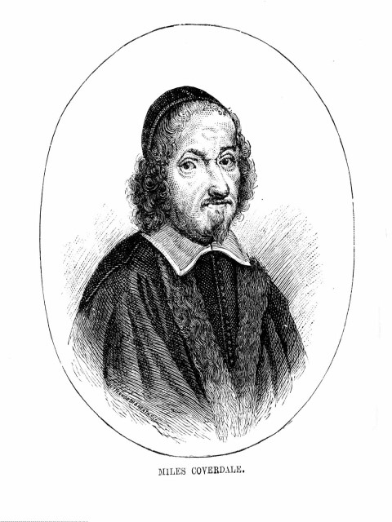

Coverdale uses these translations in his 1536 Bible. From this work, Coverdale revises and edits it into the Great Bible. The Great Bible of 1539 is the first Bible authorized in English under Henry VIII. Henry VIII commanded that every church was to have a copy of the Great Bible so that all could read and know the scriptures.

Miles Coverdale, unlike William Tyndale, obtained the backing of the King of England to translated and distribute the Great Bible throughout England. Scholars differ as to the year this Bible appeared in all the churches in England. Some say it appeared in 1539, while others date it at 1540. Other translations that appeared in England include: The 1560 Geneva Bible; the 1568 Bishops’ Bible; and the 1582 Roman Catholic English translation of the New Testament.

William Tyndale. The New Testament: 1526, ed. by W. R. Cooper. The British Library. London, England. 2000.
Ibid, 97.
Brian Moynahan. God’s Bestseller: William Tyndale, Thomas More, and the Writing of the English Bible – A Story of Martyrdom and Betrayal. St. Martin’s Press. New York, New York. 2003, 33.
John D. Long. The Bible in English: John Wycliffe and William Tyndale. University Press of America. Lanham, Maryland. 1998, 101.
Ibid, 106.
Ibid, 106.
Levi Franklin Gruber. The First English New Testament and Luther: the Real Extent to which Tyndale was Dependent upon Luther as a Translator. Lutheran Literary Board. Burlington, Iowa. 1928, 27.
Ibid, 63.

