Newsbrief: Translating the Bible into the Vernacular in the early Reformation Period
The Middle Ages witnessed no universal and absolute prohibition of vernacular translations of the Bible and their use by the clergy or laity. The central issue surrounding the increased reading of the Bible in the half-century before the Reformation was the problem of biblical interpretation, not of biblical authority. The authority of Scripture was inseparably bound up with the church’s teaching tradition and with the church’s own authority as the guarantor of the “proper” interpretation and use of the Bible. Increased familiarity with the Bible inescapably raised the question of whether the church’s teaching tradition was at all points’ faithful to the Scriptures themselves. By the early 1520’s the “rediscovered” Bible had become a revolutionary force.
Humanism in the late 15th and early 16th centuries was often connected with religious thought. Religious reform of the Roman Catholic Church and nationalistic ideas coalesced into translating the Bible into the vernacular. Each of the major European powers had important humanists who made major contributions to intellectual thought at the time.
Greek and Hebrew were becoming popular languages to study at the universities throughout Europe. Many seminarians and university scholars studied Greek and Hebrew as well as Latin. Partly as a result of the humanist emphasis on the sources, but even more in consequence of the invention of printing, the latter half of the 15th century witnessed a wide distribution of the Bible in the Vulgate and in translation.
In 1500, no less than 92 editions of the Vulgate were published. The first complete German Bible was printed in 1466. The New Testament was printed in French in 1477, the whole Bible ten years later. A Spanish Bible was printed in 1478, but it was proscribed and burned; another translation appeared in 1492. Two independent Italian versions were printed in 1471. In the Netherlands, the Old Testament minus the Psalter was printed in 1477, to be followed in 1480 by the Psalms. Two Czech Bibles appeared in 1488 and 1489. If England had no printed Bible before the Reformation, many manuscripts of the Wyclifite Bible were in circulation.
Martin Luther published his translation of the New Testament in 1522. His Old Testament translation was published in 1534, when the whole of the vernacular German Bible was published.
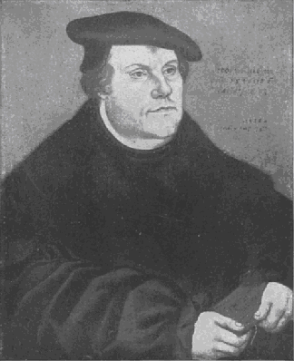
The Italian vernacular Bible was translated by Antonio Brucciolio. The Italian translation of the New Testament was printed in 1530, and the whole of the Bible in 1532. The French translation of the Bible was published in 1535. Pierre Olivetan translated the Bible into French while in Switzerland.
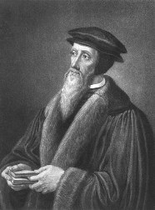
The first full English translation of the Bible was published in 1535. (For more on this topic see the newsbrief entitled “Early Translations of the Bible into English”)
The translation of the Bible into the vernacular gave everyone (everyone who could read) access to scripture. Today the Bible has been translated into thousands of languages throughout the world. Anyone with the ability to read and/or hear has access to the Bible. The Bible has even been translated into braille for individuals who are blind.
The courage it took for the men who translated the Bible in the early Reformation period is awe-inspiring. They risked their lives so that anyone who wanted to could read the Bible in their own language. Many of these brave men died a brutal death as heretics and others survived to live a long time, continuing to work to reform the church. It is thanks to these brave individuals that you and I can sit down, pick up our Bible and read it, in our own languages, whenever we want.

Williston Walker, Richard A. Norris, David W. Lotz, Robert T. Handy. A History of the Christian Church, 4th Edition. Scribner. New York, New York. 1985. 413.
Ibid, 412.
Ibid, 412-413.
Ibid, 506.
Ibid, 506.

