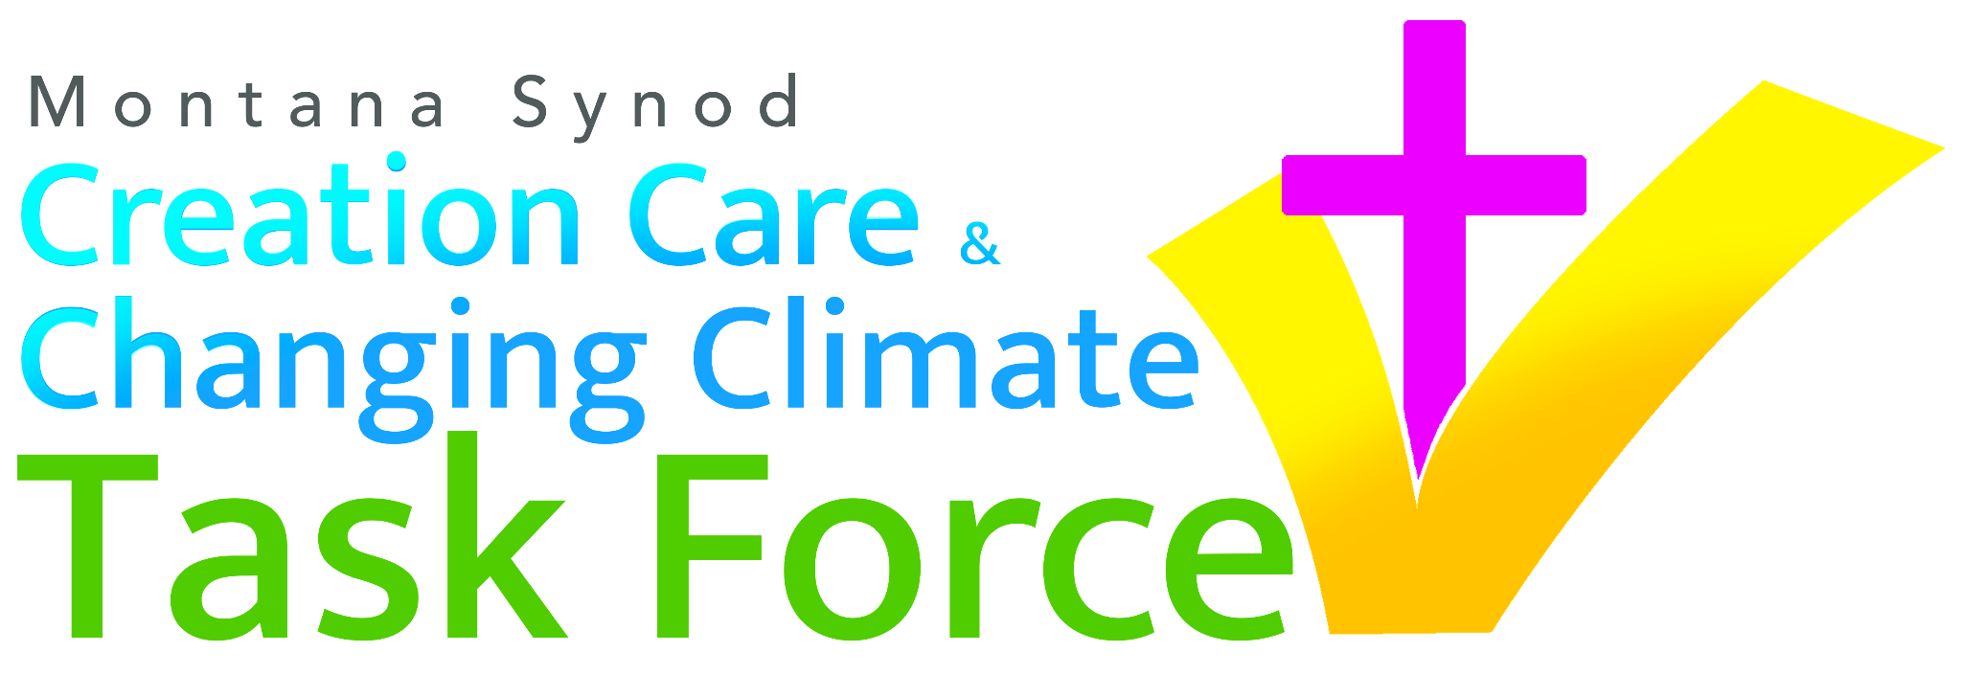

To Our Colleagues in Christ,

The earth is the Lord’s and all that is in it, the world, and those who live in it,
for God has founded it on the seas and established it on the rivers. Psalm 24:1-2

As Lutheran Christians, we take God’s gift of baptism and our baptismal vows seriously. Those vows conclude with the familiar words that guide our individual and corporate response to the power of the Spirit. We believe that baptism will help us to “proclaim Christ through word and deed, care for others and the world God made, and work for justice and peace.” (Baptism, ELW)

As a church, we are often better at talking about the ‘proclamation through word and deed’ aspects of the baptismal life. The promise to care for “the world God made” can seem both less important and too politically charged to get as much attention, even though it receives equal weight. Creation care is an integral and significant aspect of the life of discipleship.

2023 is the 35th anniversary of the adoption of Caring for Creation: Vision, Hope, and Justice, the ELCA’s social statement on environmental stewardship and responsibility. From the statement: “We are called to live according to God’s wisdom in creation (Proverbs 8)... In our time, science and technology can help us discover how to live according to God’s creative wisdom.” (Caring for Creation, 3)

In 2019, the Montana Synod Assembly voted to create the “Creation Care and Changing Climate Task Force”. This Task Force was tasked with the challenge of helping God’s church in Montana have a stronger voice in promoting solutions and opportunities connected with our changing climate and caring for our natural surroundings. It was also created to build bridges between our congregations, situated across Montana and northern Wyoming in communities with vastly different political, social, and economic realities. The Task Force was empowered to prayerfully discern some “God’s creative wisdom” in how we can deal with the challenges at hand, while trusting God’s providence for the future of creation.

We, your Synod Task Force, are here to be in relationship with you on this journey.

Made up of church members and clergy from across the wide span of our Synod, the Task Force is working on four pillars of our mission: solar power, regenerative ranching, worship opportunities and liturgy materials, and youth engagement.

- Encouraging and Supporting the Move to Solar: A tangible, public, and (semi-) immediate way to care for creation and steward our resources is to install solar panels on our properties. Our Savior’s Lutheran Church in Bonner, Emmaus Campus Ministry in Missoula, Hope Lutheran in Anaconda and Christ the King in Bozeman have successfully switched to solar power, and other ministries in the Synod are following suit. The Task Force would love to talk to your congregation about the theological and practical reasons for going solar. There are potential state and federal financial incentives and grants that the Task Force can discuss with your council. Solar can be a win for budgets and for creation.
- Regenerative Ranching and Grassland Management Partnership: As a Synod with at least 63% of our land in farming and ranching, we care about both the immediate and long-term health of soil, air, and water. The Task Force has been exploring a partnership with the Western Sustainability Exchange, which supports local ranchers and ranch organizations in adopting regenerative grazing practices that both boosts grass and soil health alongside transferring carbon from the air into the ground. There are many ways in which churches could help in this process and the CCCCTF continues to diligently find ways to meaningfully get faith communities involved.
- Worship Opportunities and Liturgy Materials: Pastor Julia Seymour and Jacob Kvale (formerly of FLBC) continue to look for ways in expanding and deepening the Montana Synod’s new liturgy: Calling Mountains, Singing Plains (available on the Montana Synod website). This liturgy, complete with Prayers of Intercession for each Sunday, can be used in full or in part to help pastors and congregations appreciate the rich and ancient connections between our Scripture, tradition, faith, and creation. Members of the Task Force are available to help you tailor this liturgy even more specifically to your setting.
- Youth Engagement: Since the wellbeing of creation significantly impacts the future of our youth, we hope to include our Synod’s younger members in our work. We are still discerning what that engagement will look like, and we would welcome your suggestions and energy.

As fellow workers in God’s good creation, we would like to help you and your congregation fulfill the creation care aspect of your baptismal vows. We can advise and guide you through the move toward more sustainable energy, provide information about regenerative ranching, or walk you through the use of a Montana-based liturgy. A video summary of these offerings is available here. We’ve started the conversation, and we’re inviting you to join us. Below you will find the contact information for the Task Force members, and you can email us with any questions related to our focus. Let us work together, united as Christ’s body, in keeping all parts of our baptismal vows.

With our gratitude for God’s good creation,
The MT Synod Creation Care and Changing Climate Task Force

Solar:
Pastor Eric Huseth (Bonner) at pastor@oursaviorsbonner.org
Dale Olson (Bozeman) at dnaolson9151@gmail.com
Alex Tooley (Great Falls) at alextooley@icloud.com
Regenerative Ranching:
Patrick Miller (Bozeman) at patrickdouglas.miller@gmail.com
Brian Koukol (Bozeman) at bkworkingstuff@gmail.com
Pastor Bonnie Novak (Wolf Point/Nashua) at 4novaks@nemont.net

Liturgy:
Pastor Julia Seymour (Big Timber) at pastorjuliaseymour@gmail.com
Jacob Kvale (Missoula) at jacobkvale@gmail.com

Youth:
Pastor Megan Hoewisch (Havre) at pastormegan.flc@gmail.com
Kierstan Schaeffer (Bozeman) at Kierstenschaeffer@icloud.com

Synod Council Liaison:
Dr. John W. Sheppard (Belgrade) at jsheppa2@gmail.com

